Prior Knowledge needed:
- EJ Job Number
- At least 1x Item must be loaded onto job already (can be barcoded or non barcoded)
- Text file of barcodes

To Batch Load:

Open EasyJob

Select Projects In top navbar, and then BatchLoad

This will open up a new screen

In this new window, go to the top right and click Import
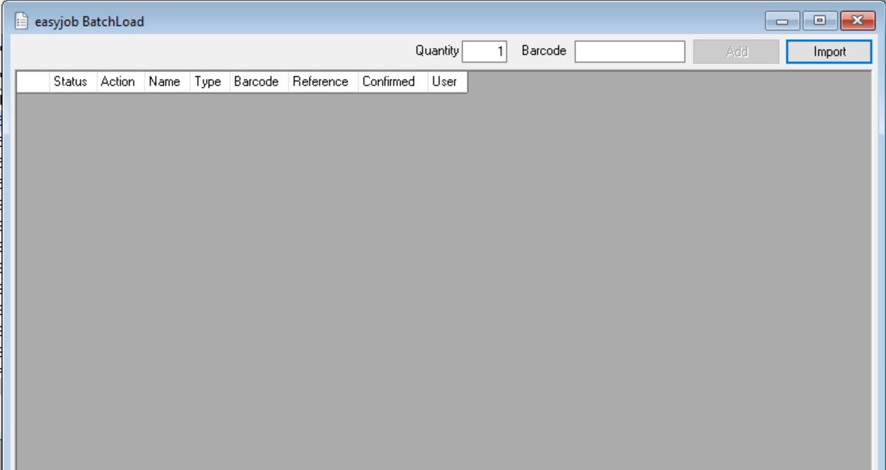

Make sure "Project / Job" is selected and then click "OK"
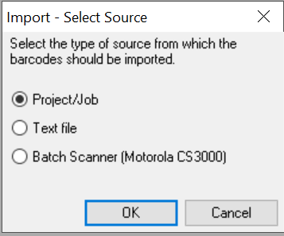

Next in the job search popup - search for your job by number / name and Click OK
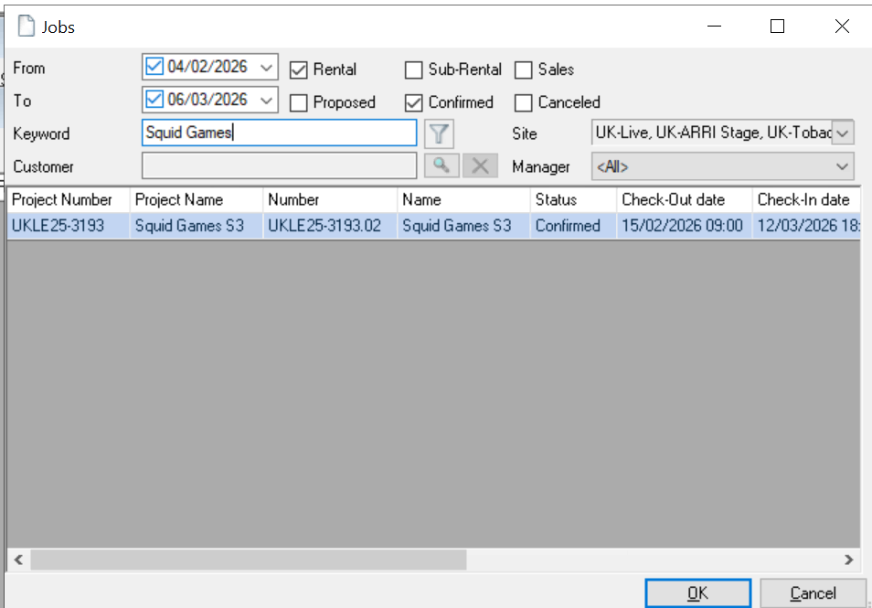

Select one of the items by ticking the first box (first item’s checkbox) and click OK
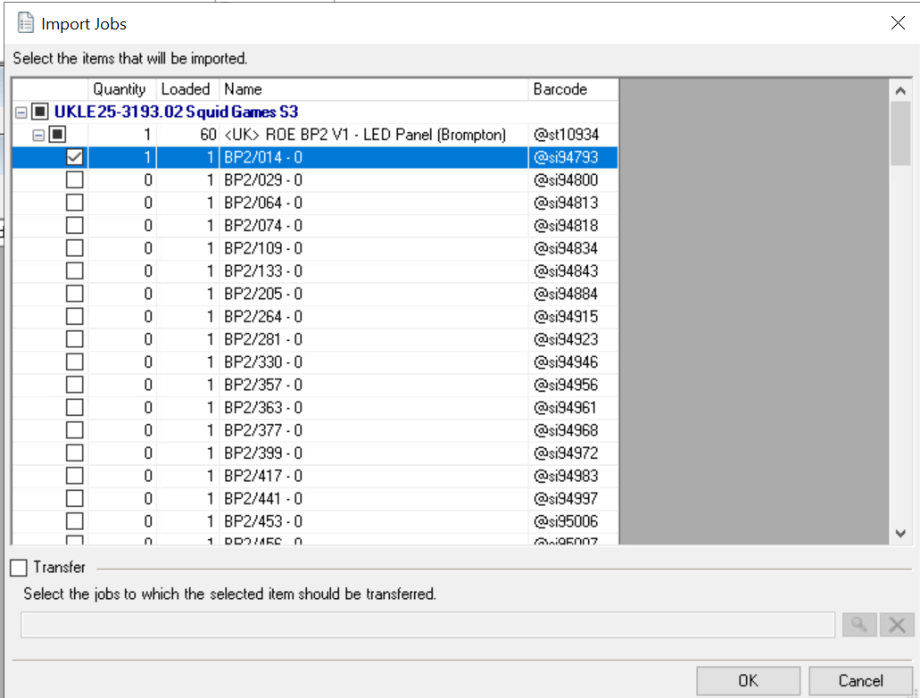

This should add that single item to the batch load page.
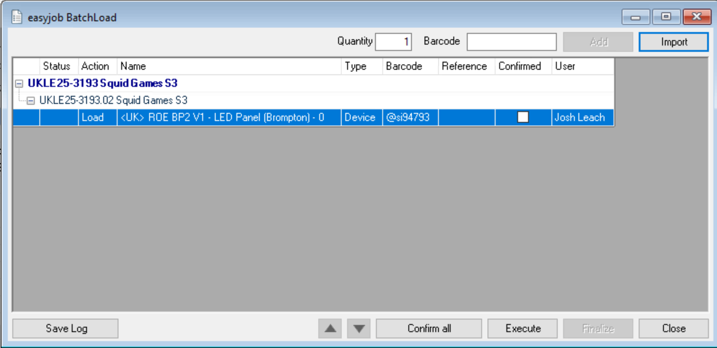

To add your new barcodes to add, click the “Import” button again, this time selecting the “Text File” and pressing OK

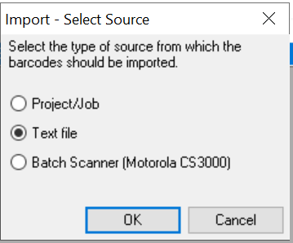

It will now bring up a file explorer window for you to find your text file of barcodes
Navigate to your computer by: This PC -> Local Disk (C: On ***) -> Users -> (*YOUR USERNAME*) -> OneDrive – NEP Group, Inc) From here you can find your text file of barcodes.

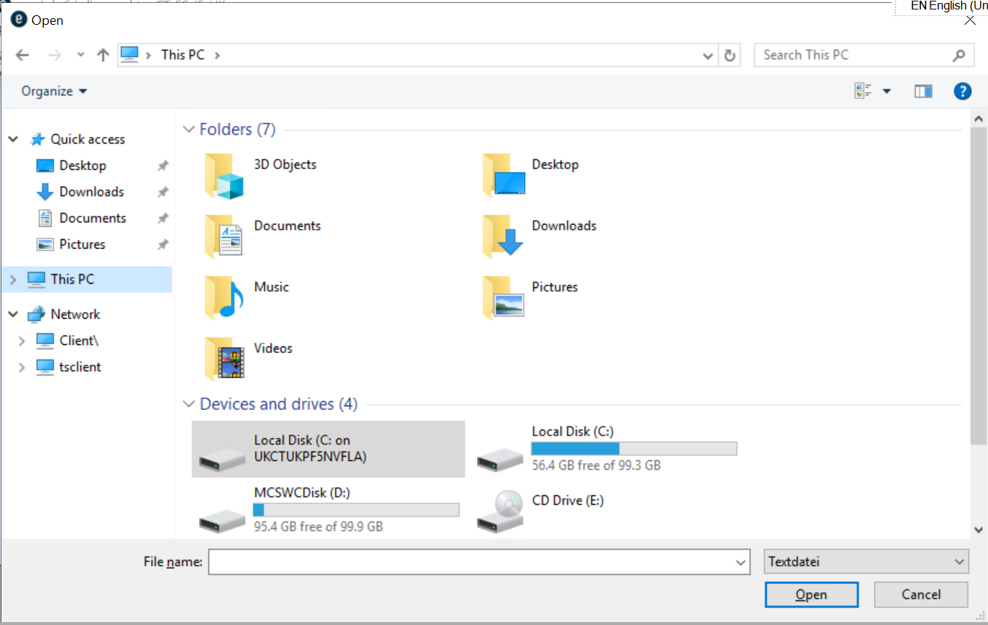
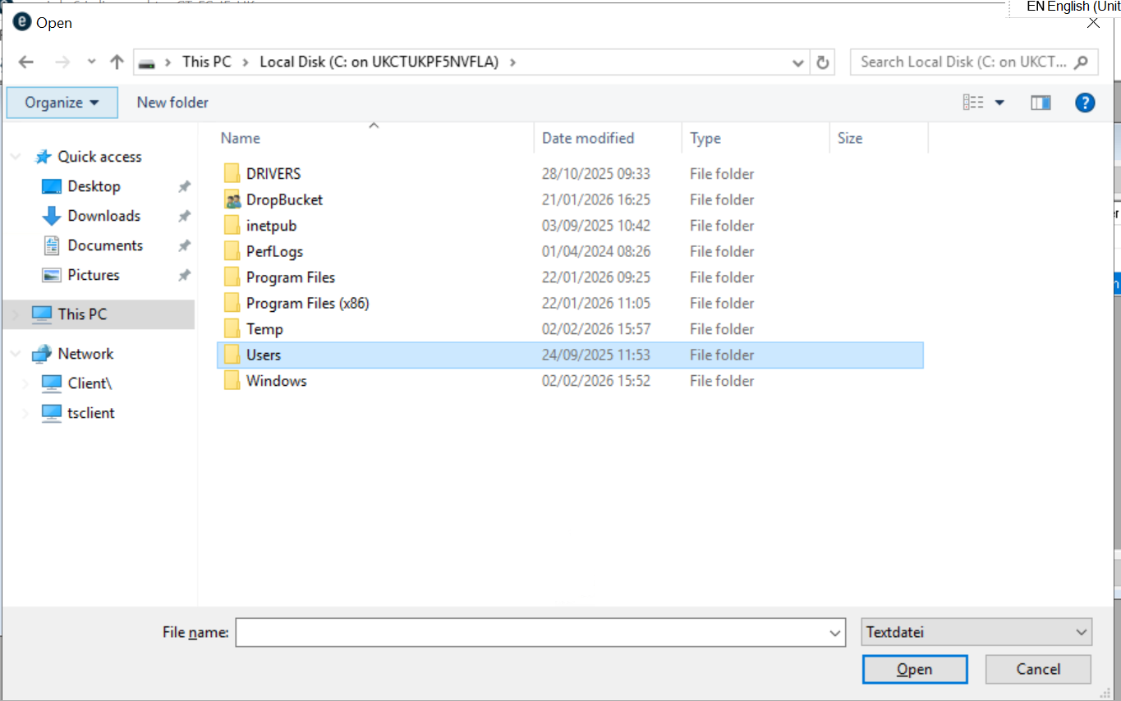
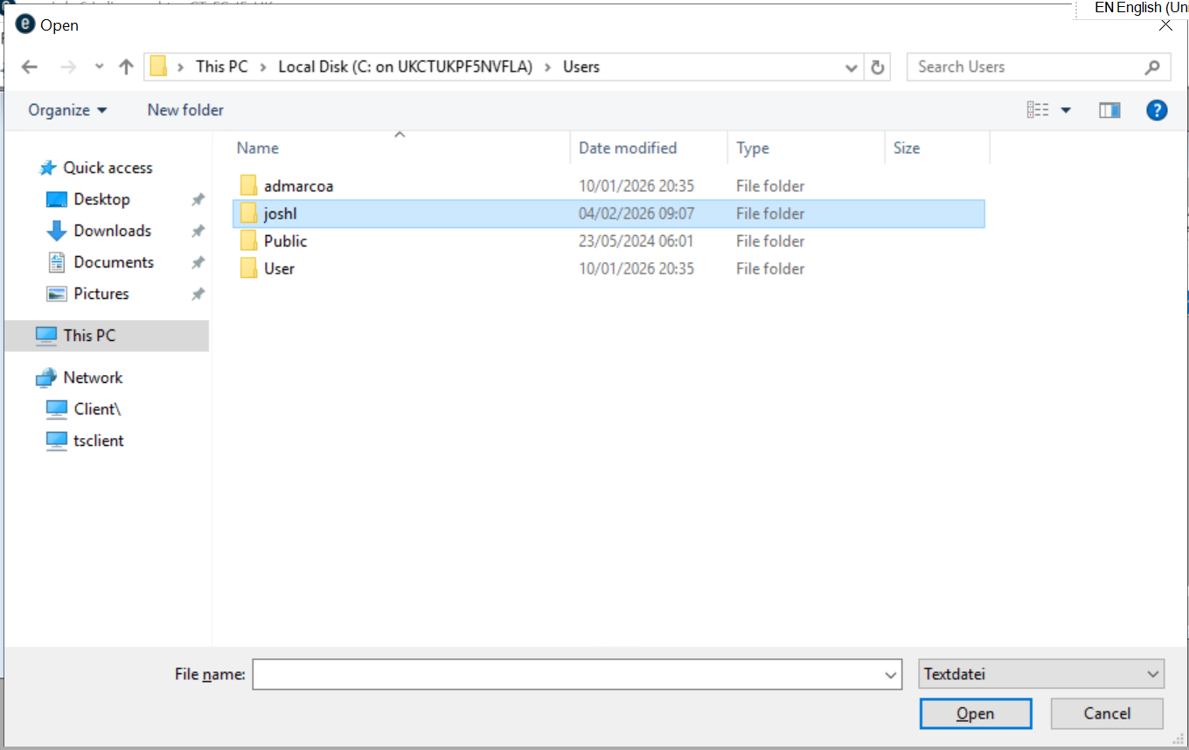
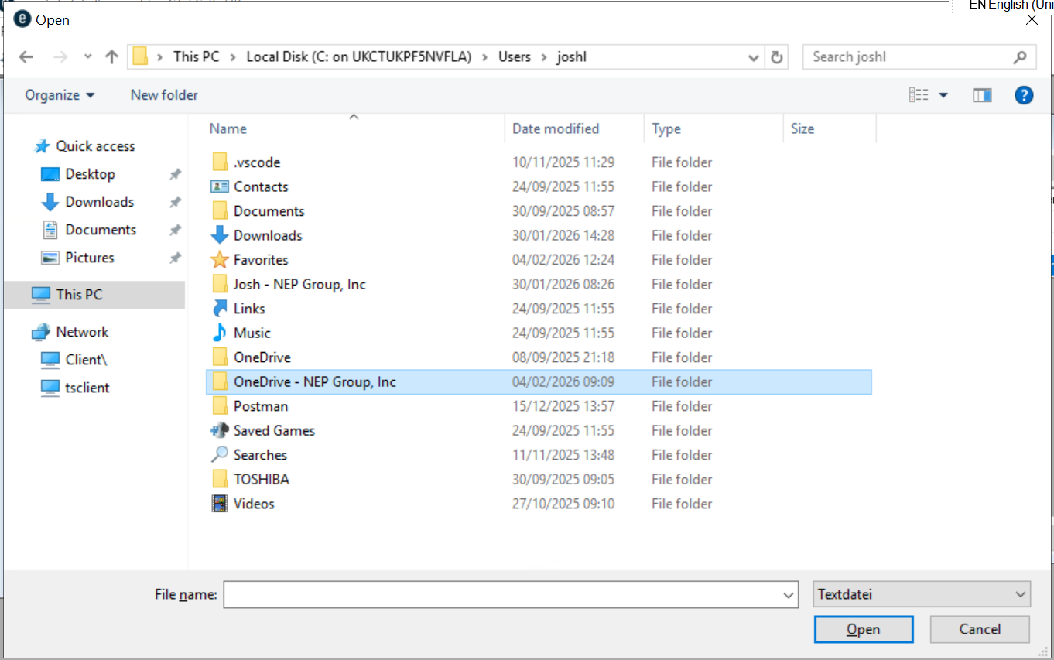

Now search for your file at press “Open”
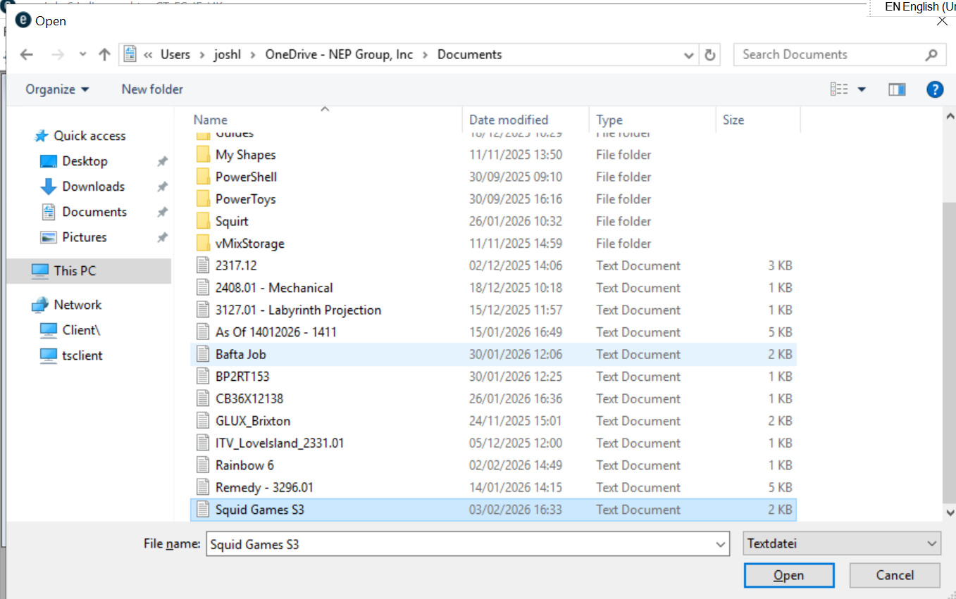

This should add your new barcodes to the batchload screen.
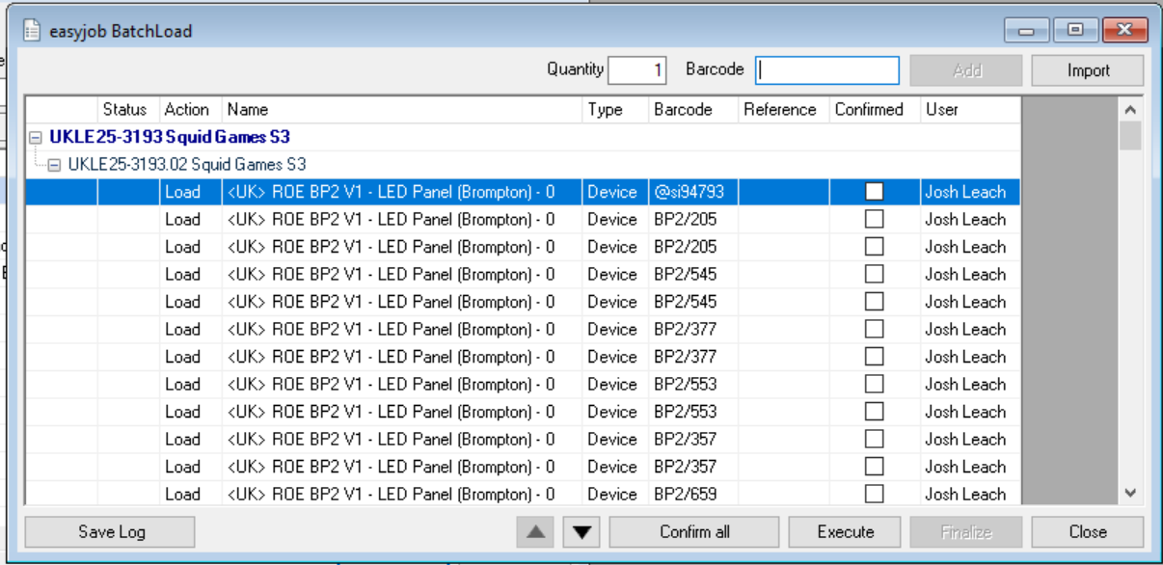

Check through this list and make sure there is no errors.
Click “Confirm All” – this will add a tick in the checkbox for each item.
Click “Execute” and in the popup asking to Start the process press “Ok”

